FEI CALENDAR APPLICATION FORM 2025
Event Details
Name of Event:
Name of Organisation running the FEI Event:
Event Venue Location:
State (please select): | NSW / VIC / QLD / WA / SA / TAS / NT / ACT
FEI Competition Start Date:
FEI Competition End Date:
Discipline/s (please select): | Eventing / Dressage / Jumping / Para-Dressage / Endurance / Vaulting / Driving
FEI Event Category: (inclusive of star rating & all classes required e.g. CCI3*-S or -L, )
FEI Competition will be run Indoor/Outdoor for the main class (please select): | Indoor / Outdoor

Contact Details – for all correspondence
Contact Name:
Contact Email Address:
Contact Phone Number:
Event Mailing Address:
Schedule Admin Contact Name:
Schedule Admin Contact Email Address:
Schedule Admin Contact Phone Number:
Organisation ABN:
Is the organisation registered for GST (please select): | Yes / No
Do you accept the FEI charges will be billed to this organization (please select): | Yes / No
Name and email for forwarding of FEI fees if different to above:

Signature: __________________________________________

Please send your FEI Calendar Applications by the closing date of 5pm 1st August 2024 to: Equestrian Australia
FEI Liaison Officer
laura.wallace@equestrian.org.au

EVENT PAGE TEMPLATE
To have your event listed on Equestrian Australia’s website Calendar, please complete and return the below form to laura.wallace@equestrian.org.au
Discipline/s:
Name of Event:
Start Date: |  | End Date:
Event Organiser/ Organising Committee:
Email contact:
Event Location (precise venue’s address):
Event’s website:
Facebook Page link:
Twitter Page link:
Instagram Page link:
Live streaming link:
Live score link:
Please supply a HORIZONTAL photo or event’s banner to illustrate your event. Example :
(For example, it can be your Facebook page’s top header banner called COVER PHOTO)
Size of the banner needs to be 1130 x 430 pixels, see below.
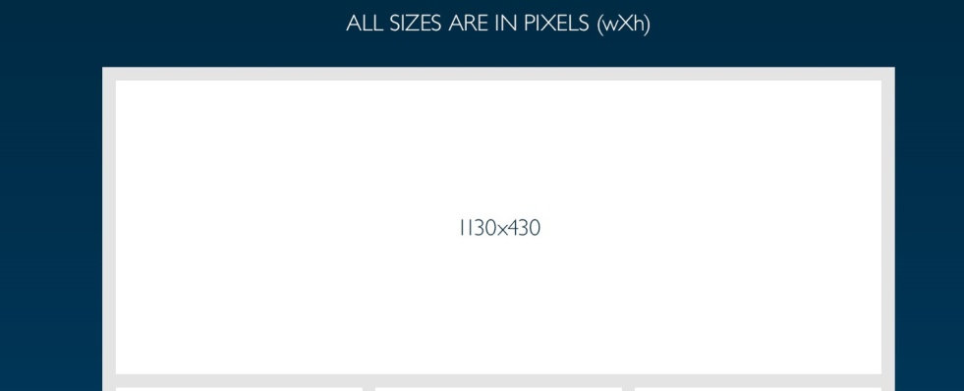

About Your Event:
(Write a short text introducing your event. Level and what the general public can find)

