

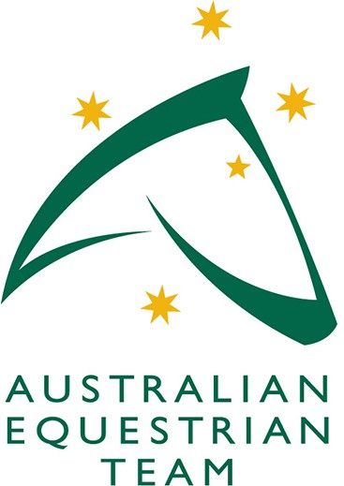EQUESTRIAN AUSTRALIA TEAM SUPPORT APPLICATION

FEI Endurance World Championship 2026

|  |
| --- |
| Enquiries and Submission:  Please email this form and any additional information that may assist your application to Dianne Saunders, EA High Performance Sport Manager, [di.saunders@equestrian.org.au](mailto:di.saunders@equestrian.org.au) by Monday 28.4.2025  Please tick the position you are applying for:   * Chef d’Equipe * Team Veterinarian |

CON S E N T OF APPL I C A N T :

**Signed:**  **Date:**

I hereby make my application to be considered for the role indicated above on the EA Endurance Team Support crew and if selected, agree to abide by the rules and regulations of the competition and EA.

|  |  |  |
| --- | --- | --- |
| Per so n a l Deta i l s : | | |
| Name: | | Phone: |
| Street Address: | | |
| Email: | | |
| EA Member No: | FEI Member No: | |

|  |
| --- |
| The EA Australian Equestrian Team Support position you are applying for requires your support leading into and at the 2026 FEI World Championship. Your application is made with the understanding of commitment in time and contribution with reference to the relevant EA Position Description. Please provide information to support your application including relevant experience and attributes to Endurance that would allow the Selectors to make an informed choice in consideration of filling the role/s offered. The Selectors decision is final. |
|  |